1. Format all cells -> Autofit column width
2. Change format of START and STOP to long date as they are in DateTime format (FHIR compatible)
3. Set format of BASE_COST and TOTALCOST to USD Currency
4. Fill blank values with NA
5. Remove ‘Disorder’ from all descriptions to increase readability

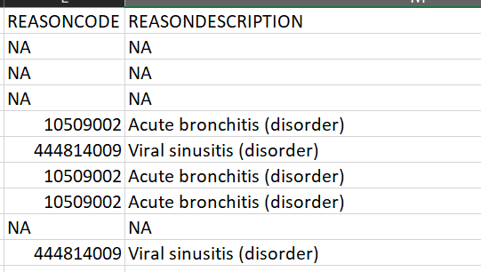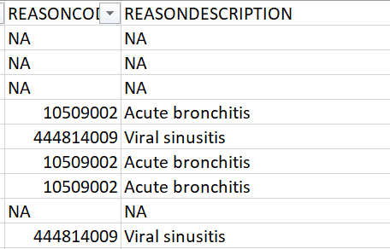

1. No duplicate values found
2. Text case inconsistency

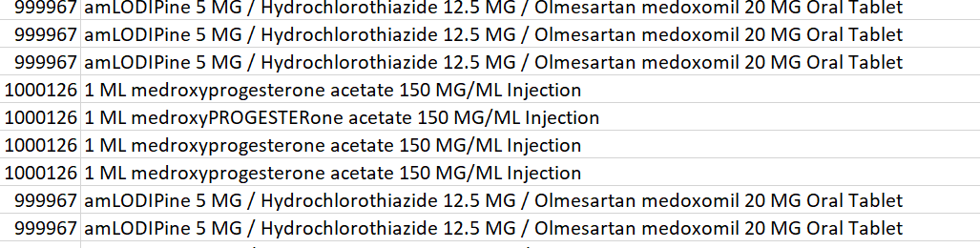

Use proper() function to convert to title case

